# ......................................................................................................................................................

**NAME – VAIBHAV NEGI COURSE - MCA (2nd - ‘B’) STUDENT ID - 20711097**

**......................................................................................................................................................**

**Problem statement**: Create a wired LAN in packet tracer.

**Objective**: To understand how to create a wired LAN using switch in packet tracer.

# Description:

**STEP 01-** Open PACKET TRACER and go to the bottom left side of packet tracer window and then click on **SWITCHS** and select icon of switch 2950-24 then drag and drop that switch icon from it in the workspace.

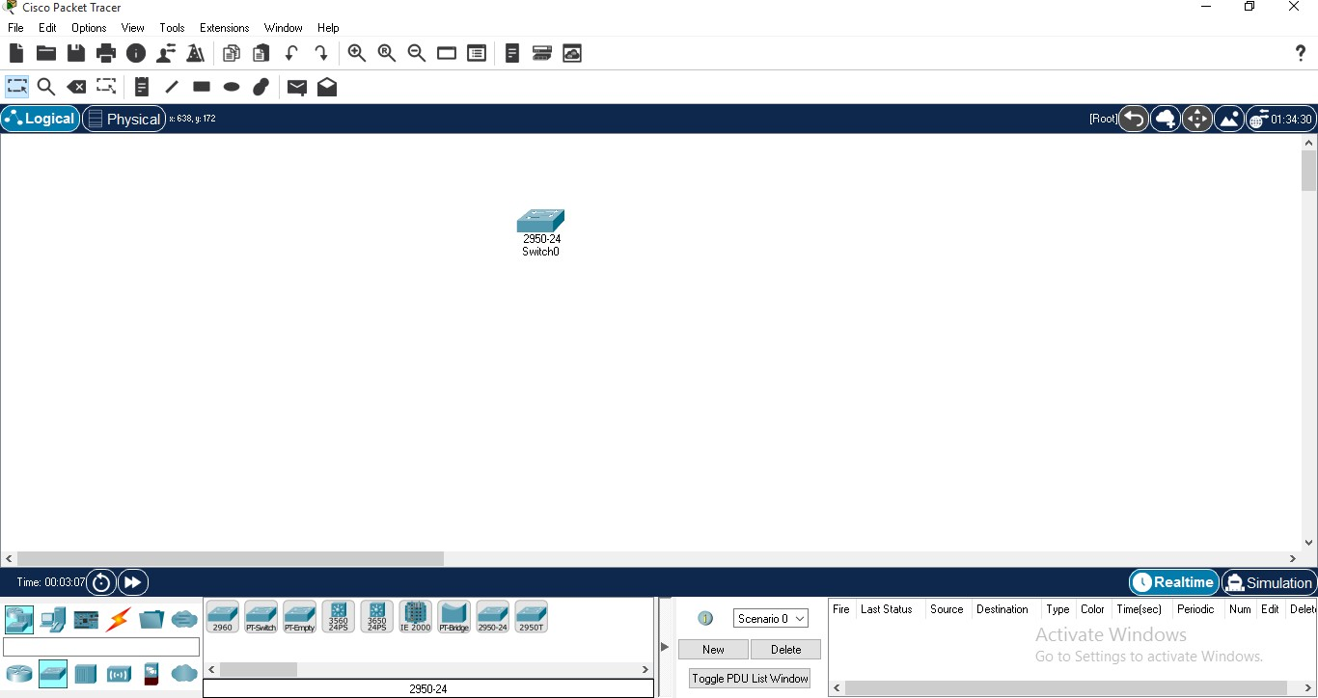

**STEP 02 -** Go to the bottom left side of packet tracer window and then click on **END DEVICES**

and select icon of PC then drag and drop 4 PC icons from it in the workspace.

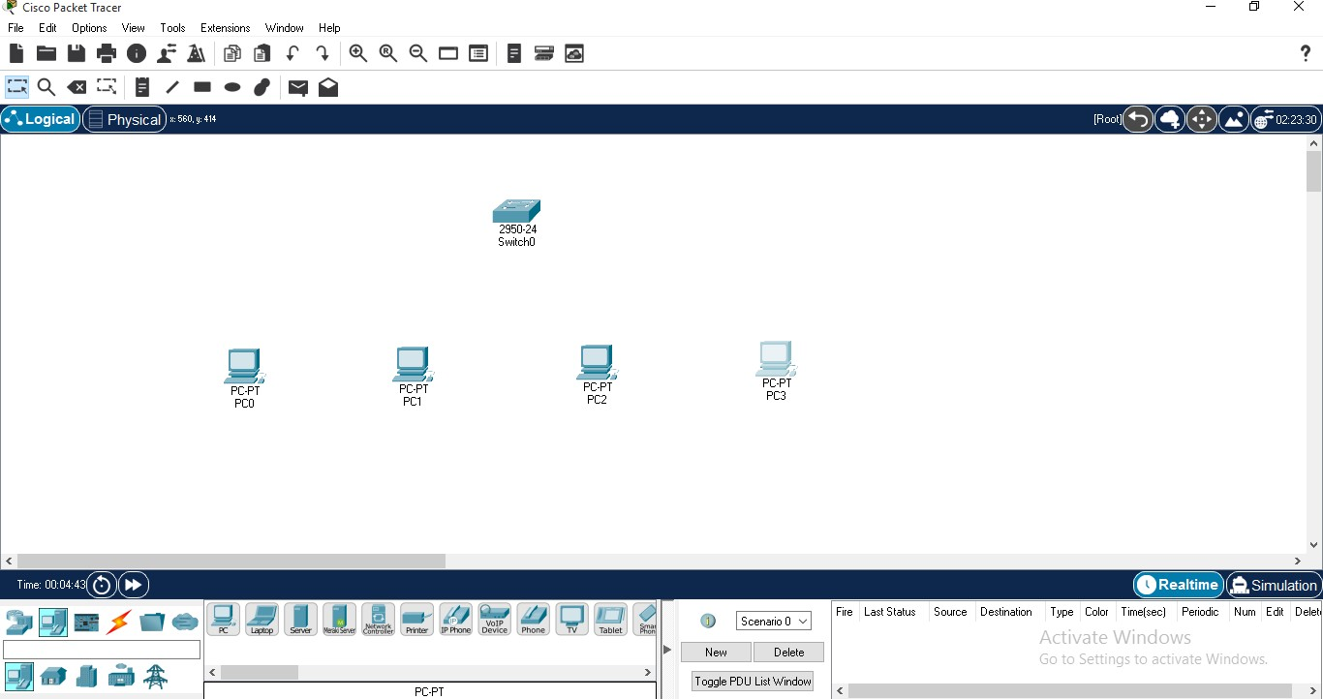

**STEP 03 -** Then again go to the bottom left side of packet tracer window and then click on **CONNECTIONS** since we are using the **different devices** therefore select **Copper Straight-Through cable.** Then right click on PC0 and click on FastEthernet0 and join it with switch.

Since switches have many ports so we will use **FastEthernet0/1 for PC0.**

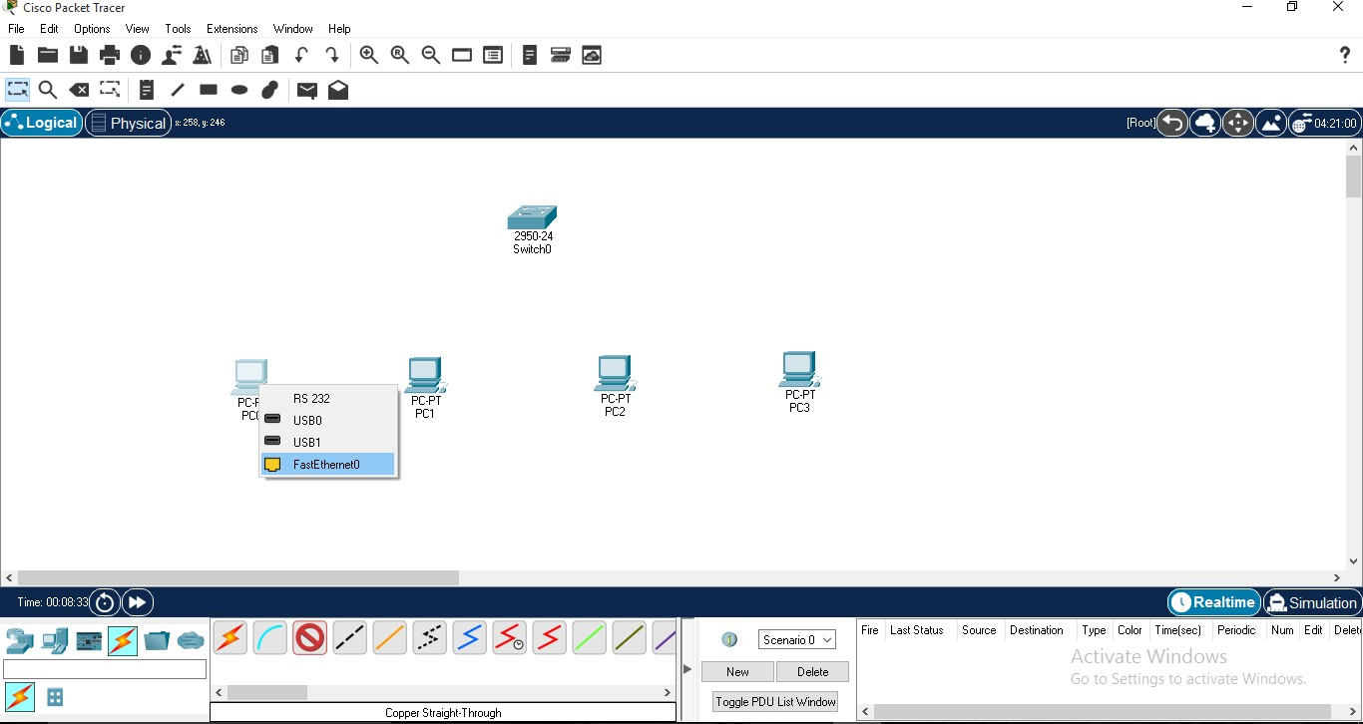

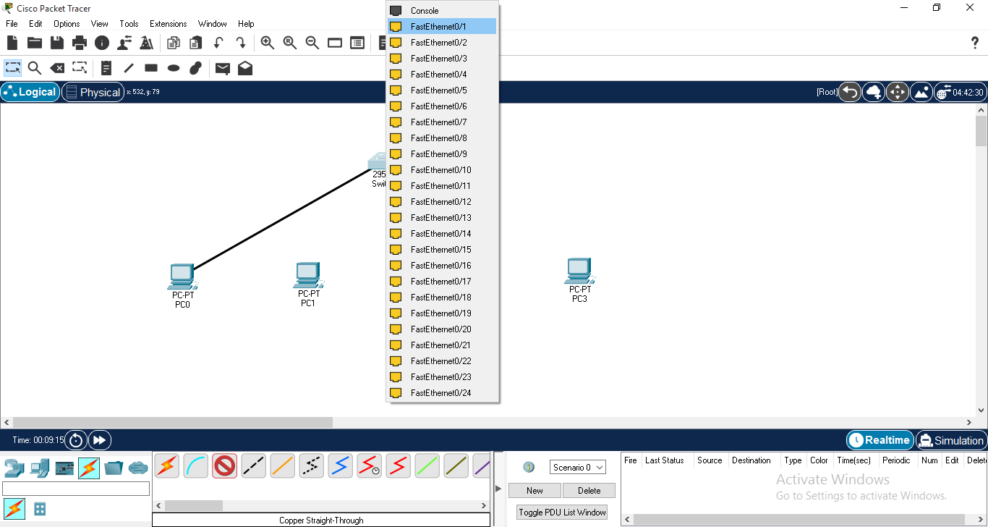

**STEP 04 -** Repeat above step for all other PC’s as well.

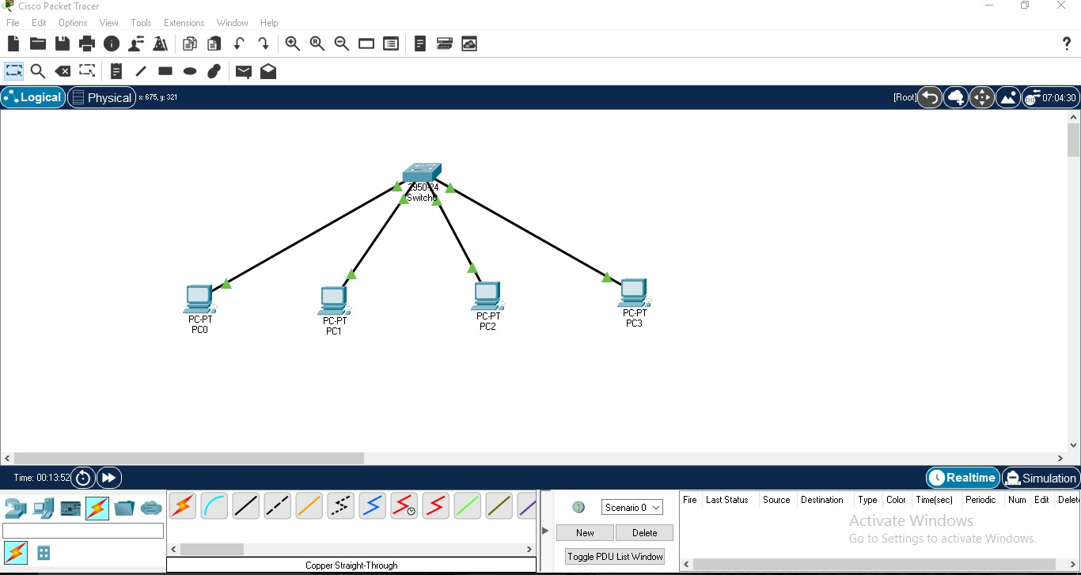Switch port for PC1 is **FastEthernet0/2.** Switch port for PC2 is **FastEthernet0/3.** Switch port for PC3 is **FastEthernet0/4.**

**STEP 05 -** Now we will configure the IP address for all PC’s.

Click on PC0, a window will open and in that window click on the **desktop tab**. Then Click on IP Configuration.

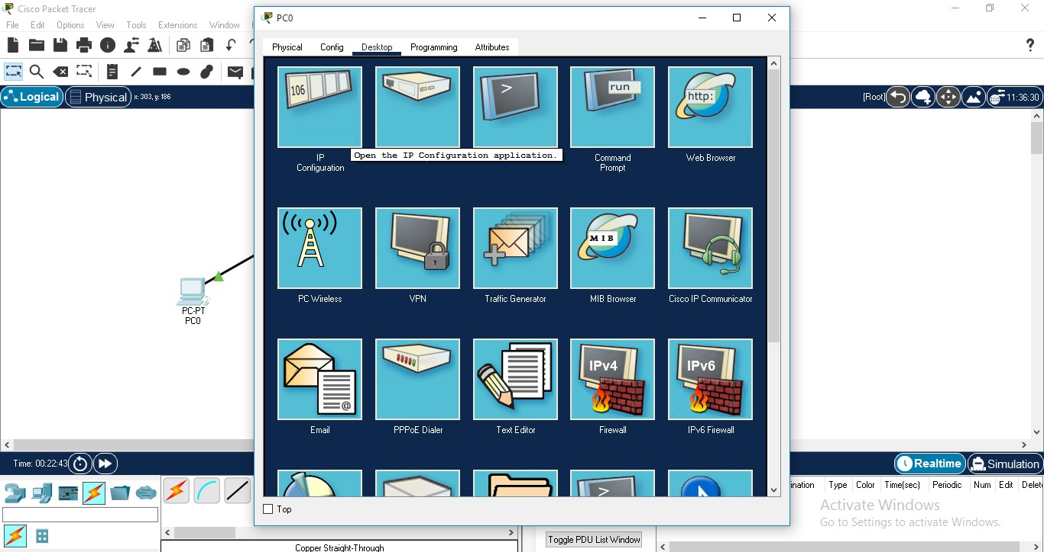

**STEP 06 -** Select **static** option and then give IPv4 Address (**for eg. 192.168.1.1**) for PC0. After that click on Subnet Mask field it will fill automatically with default subnet mask.

After that the IP Configuration is done for PC0.

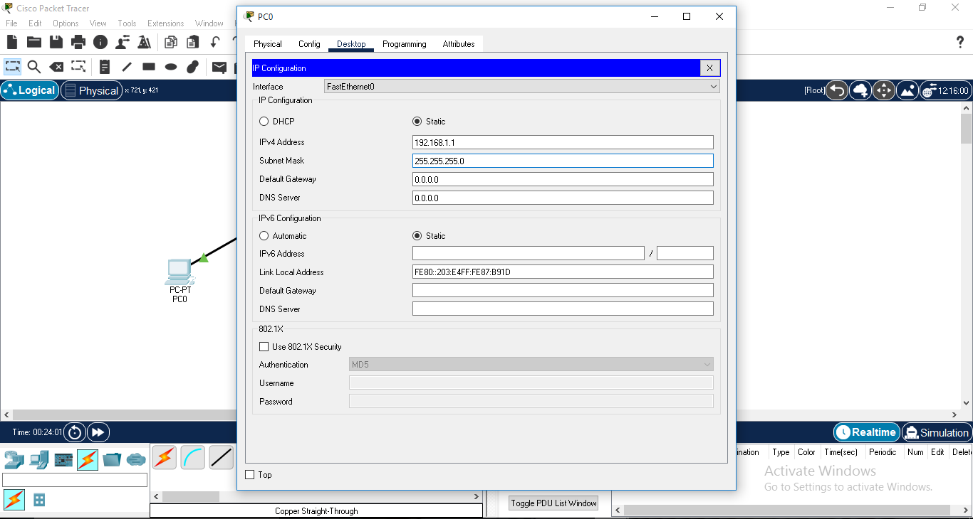

**STEP 07 -** Repeat above step for the IP address configuration of all other PC’s.

# FOR PC1, IP ADDRESS - 192.168.1.2

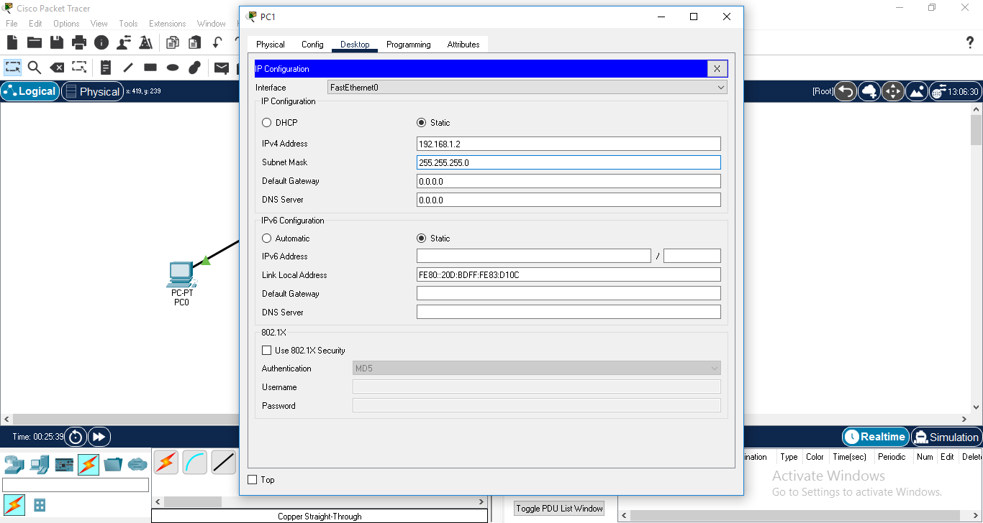

**FOR PC2, IP ADDRESS - 192.168.1.3**

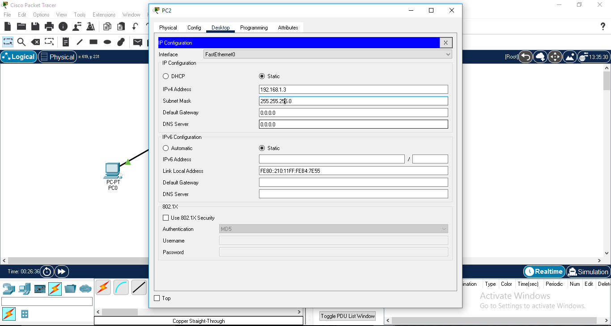

**FOR PC3, IP ADDRESS - 192.168.1.4**

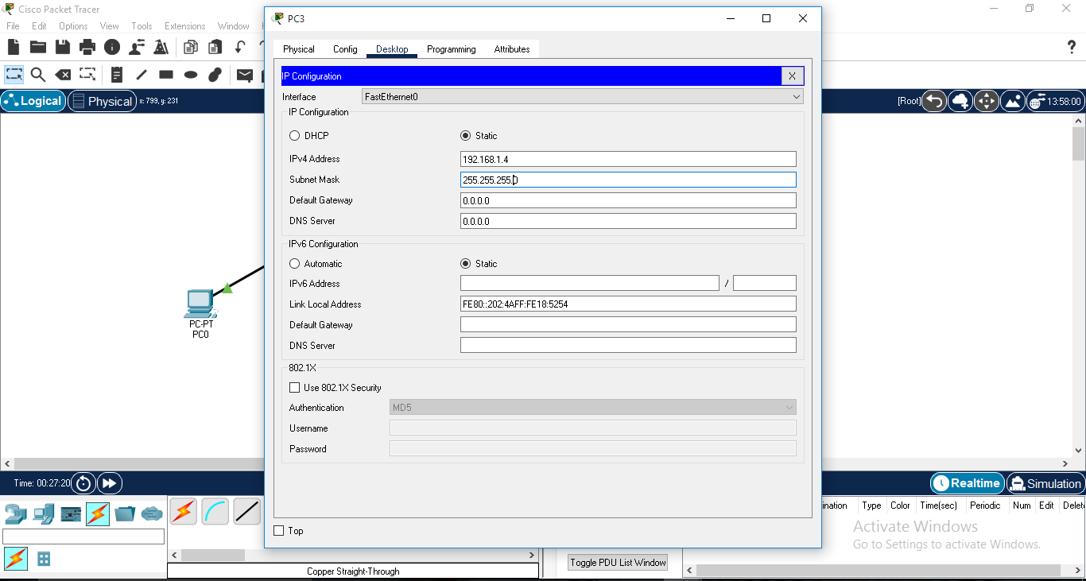

**STEP 08 -** Check our design is working or not, click on PC0 (or any other PC) then click on command prompt.

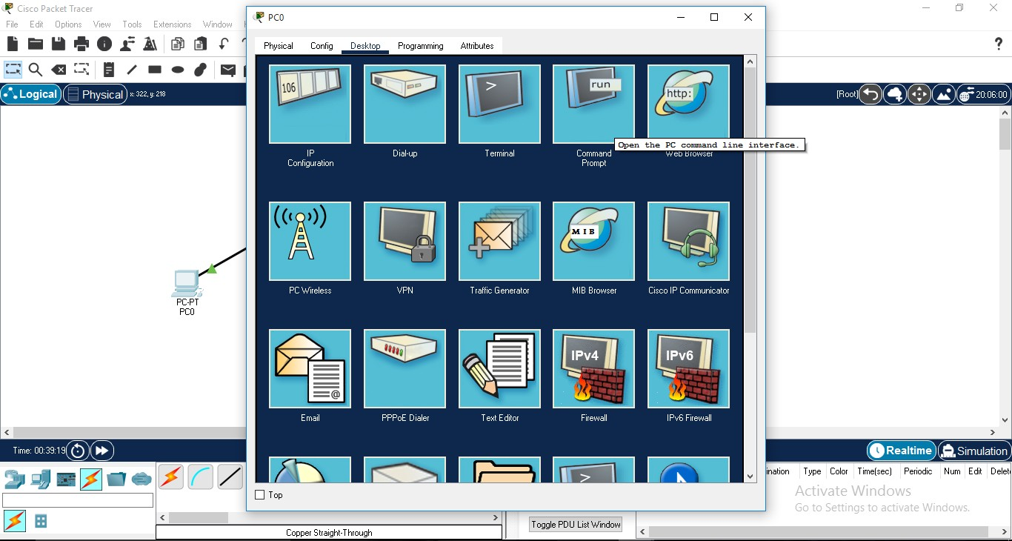

**STEP 09 -** Run **ping** command with IP address of any other PC (As we are checking on PC0 so we have to give the IP address of ANY other PC connected to switch) on terminal to check or to test the connectivity between the devices.

(We can perform same with any of the PCs as well to check connectivity using ping command.)

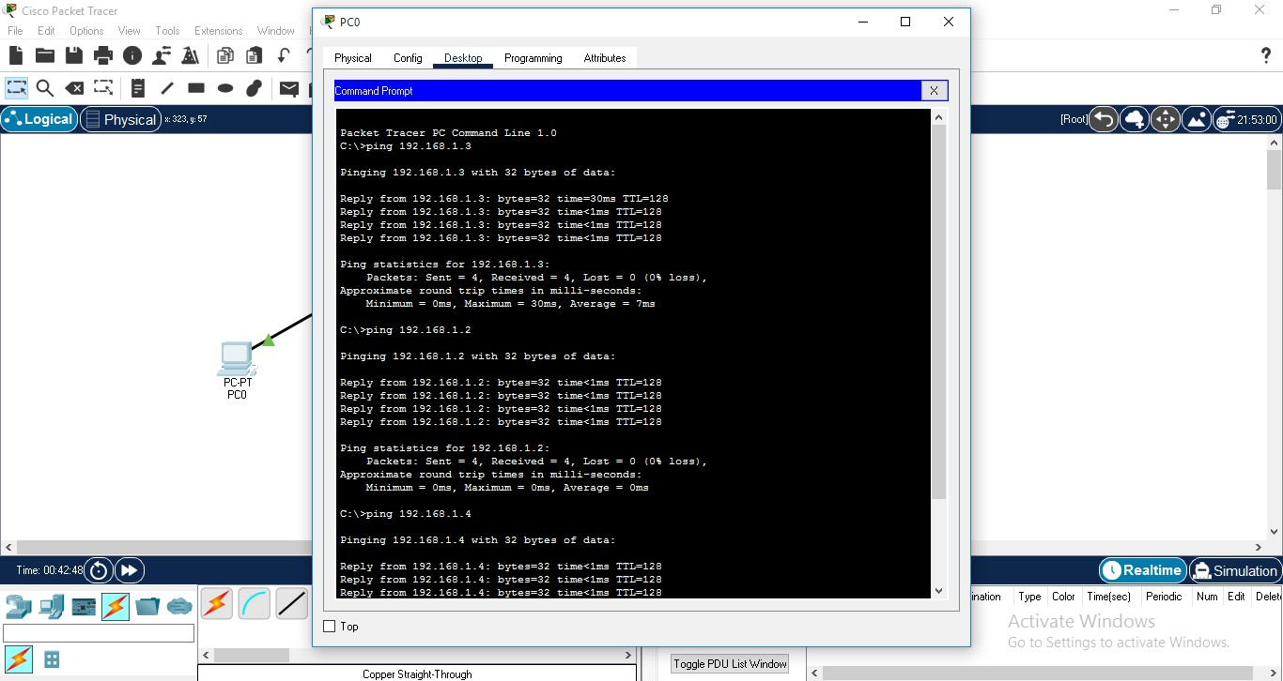

# SO, FROM THE ABOVE COMMAND WE CAN SEE THAT ALL THE SYSTEMS ARE CONNECTED TO EACH OTHER.